SAM HIGGINBOTTOM UNIVERSITY OF AGRICULTURE, TECHNOLOGY AND SCIENCES
SHUATS, Prayagraj - 211007, Uttar Pradesh, India


M.Sc. GIS & REMOTE SENSING (SEMESTER-II)
Course: Advanced Spatial Statistics & GIS Analysis
SPATIAL AUTOCORRELATION & POINT PATTERN ANALYSIS

SUBMITTED BY:  Name: N. Akshit Vinay  PID: 25MSRSGIS001  Program: M.Sc. GIS & Remote Sensing | SUBMITTED TO:  Instructor: Mrs. Arpita Esther  Assistant Professor  Dept. of Mathematics & Statistics

Table of Contents
Right-click below and select 'Update Field' to refresh page numbers dynamically.

1. SPATIAL AUTOCORRELATION: MORAN'S I & GEARY'S C 1
1.1 Spatial Data & Study Area Representation 1
1.1.1 Data Generation Methodology 1
1.1.2 Choropleth Map of Prevalence 1
1.1.3 Data Table (First 10 Rows) 1
1.2 Spatial Weights Matrix Construction 1
1.2.1 Queen Contiguity Definition 1
1.2.2 Matrix Properties 1
1.2.3 Visualisation 1
1.2.4 Alternative Weight Specifications 1
1.3 Global Moran's I Statistic 1
1.3.1 Mathematical Formulation 1
1.3.2 Interpretation Guide 1
1.3.3 Computational Results 1
1.3.4 Moran Scatterplot Analysis 1
1.4 Global Geary's C Statistic 1
1.4.1 Mathematical Formulation 1
1.4.2 Interpretation Guide 1
1.4.3 Computational Results 1
1.4.4 Comparison: Moran's I vs. Geary's C 1
1.4.5 Local Geary Index Map 1
1.5 Local Indicators of Spatial Association (LISA) 1
1.5.1 Local Moran's I Formula 1
1.5.2 Cluster Classification 1
1.5.3 LISA Cluster Map 1
2. POINT PATTERN ANALYSIS AND HOTSPOT DETECTION 1
2.1 Getis-Ord Gi* Local Hotspot Detection 1
2.1.1 Gi* Formula 1
2.1.2 Significance Thresholds 1
2.1.3 Hotspot Map 1
2.2 Discrete Point Pattern Classifications 1
2.2.1 Pattern Types 1
2.2.2 Visual Comparison 1
2.3 Nearest Neighbour Index (NNI) 1
2.3.1 NNI Definition & Formula 1
2.3.2 Calculations & Interpretation 1
2.4 Kernel Density Estimation (KDE) Modeling 1
2.4.1 KDE Surface Generation 1
2.4.2 Density Visualisation 1
2.5 Ripley's K & Besag's L-Function Multi-Scale Analysis 1
2.5.1 Mathematical Definition 1
2.5.2 Multi-Scale Results & Interpretation 1
2.5.3 Spatial Analytics Dashboard 1
3. REFERENCES 1
4. APPENDIX: FORMULAS & DATA MATRIX 1
4.1 Complete Statistical Formula Summary 1
4.2 Complete 10×10 Grid Prevalence Data Matrix 1

INTERACTIVE ANALYSIS WORKFLOW
This interactive navigator acts as a quick access console for the analysis steps. Click on the button in the third column to navigate directly to the corresponding section within the document.
Step | Analytical Workflow Component | Document Navigation Link
Step 1 | Spatial Data & Study Area: Prevalence data generation methodology, choropleth map (Figure 1), and sample matrix. | Go to Section ➜
Step 2 | Spatial Weights Matrix: Queen contiguity definition, connectivity properties, and network graph (Figure 2). | Go to Section ➜
Step 3 | Global Moran's I: Formulation, expected values, results, and Moran scatterplot (Figure 3). | Go to Section ➜
Step 4 | Global Geary's C: Local/global formulations, calculations, comparison table, and Local Geary map (Figure 4). | Go to Section ➜
Step 5 | Local Indicators of Spatial Association (LISA): Formulation, cluster classifications, and LISA cluster map (Figure 5). | Go to Section ➜
Step 6 | Getis-Ord Gi* Hotspot Detection: Formulation, z-score significance thresholds, and hotspot map (Figure 6). | Go to Section ➜
Step 7 | Point Pattern Classifications: Pattern types, visual comparison of Clustered/Random/Regular (Figure 7). | Go to Section ➜
Step 8 | Nearest Neighbour Index & KDE: NNI formulation, calculations, and KDE density surface (Figure 8). | Go to Section ➜
Step 9 | Ripley's K & Besag's L-Function: Mathematical definition, multi-scale results (Figure 9), and Integrated Dashboard (Figure 10). | Go to Section ➜

1. SPATIAL AUTOCORRELATION: MORAN'S I & GEARY'S C
Spatial statistics extends classical statistical models by explicitly incorporating geographic space as a core parameter. In geographic information science (GISc), spatial processes are fundamentally governed by Tobler's First Law of Geography, which states that 'everything is related to everything else, but near things are more related
than distant things'. This chapter examines Spatial Autocorrelation: global indicators (Moran's I and Geary's C) and local indicators (LISA and Gi*) of spatial dependency.

1.1 Spatial Data & Study Area Representation

1.1.1 Data Generation Methodology
Geographic analyses are grounded in empirical data representing real-world processes. For this assignment, disease prevalence is simulated over a 10×10 grid lattice (N=100 zones). To model a realistic spatial clustering pattern, we use a bivariate Gaussian kernel decay function. The disease prevalence P_ij for cell (i,j) is calculated using the formula:
$$P_{ij}=80·e^{\frac{-{\left(x-3\right)}^{2}-{\left(y-3\right)}^{2}}{18}}+ε_{ij}$$
Where:
P_ij = simulated disease prevalence (%) at grid cell (i, j)
80 = peak cluster amplitude (%), the theoretical maximum at the hotspot centre before noise is added e = Euler's constant (≈ 2.71828); base of the natural exponential function
x, y = spatial coordinates of the cell centroid in the 10×10 lattice (range: 0 to 9)
3, 3 = geographic centre coordinates of the simulated hotspot (X₀ = 3, Y₀ = 3)
18 = scaling factor 2σ² of the bivariate normal distribution; controls spatial spread (σ² = 9, σ = 3 units) ε_ij = spatially i.i.d. Gaussian noise representing unexplained local variation: ε_ij ~ N(0, σ² = 4.0)
Step-by-Step Computational Example — Cell (3,3) [Hotspot Centre]: Step 1: Exponent numerator = (3−3)² + (3−3)² = 0 Step 2: Exponential decay term = e^0 = 1 Step 3: Deterministic component = 80 × 1 = 80.0% Step 4: Noise term simulated = ε₃,₃ = +1.65% Step 5 (Final): P₃,₃ = 80.0 + 1.65 = 81.65% ← absolute peak value (hotspot core) Step-by-Step Computational Example — Cell (0,0) [Peripheral]: Step 1: Exponent numerator = (0−3)² + (0−3)² = 9 + 9 = 18 Step 2: Exponential decay = e^(−18/18) = e^(−1) ≈ 0.3679 Step 3: Deterministic component = 80 × 0.3679 ≈ 29.43% Step 4: Noise term simulated = ε₀,₀ = −1.03% Step 5 (Final): P₀,₀ = 29.43 − 1.03 = 28.40% ← peripheral low-prevalence cell

1.1.2 Choropleth Map of Prevalence
Figure 1 visualizes the generated dataset. Cell colors transition from cool greens (low prevalence) to warm purples (high prevalence), revealing a core-periphery distribution pattern. The highest prevalence value (81.65%) is recorded at grid cell (3,3), while boundary values decay toward zero.
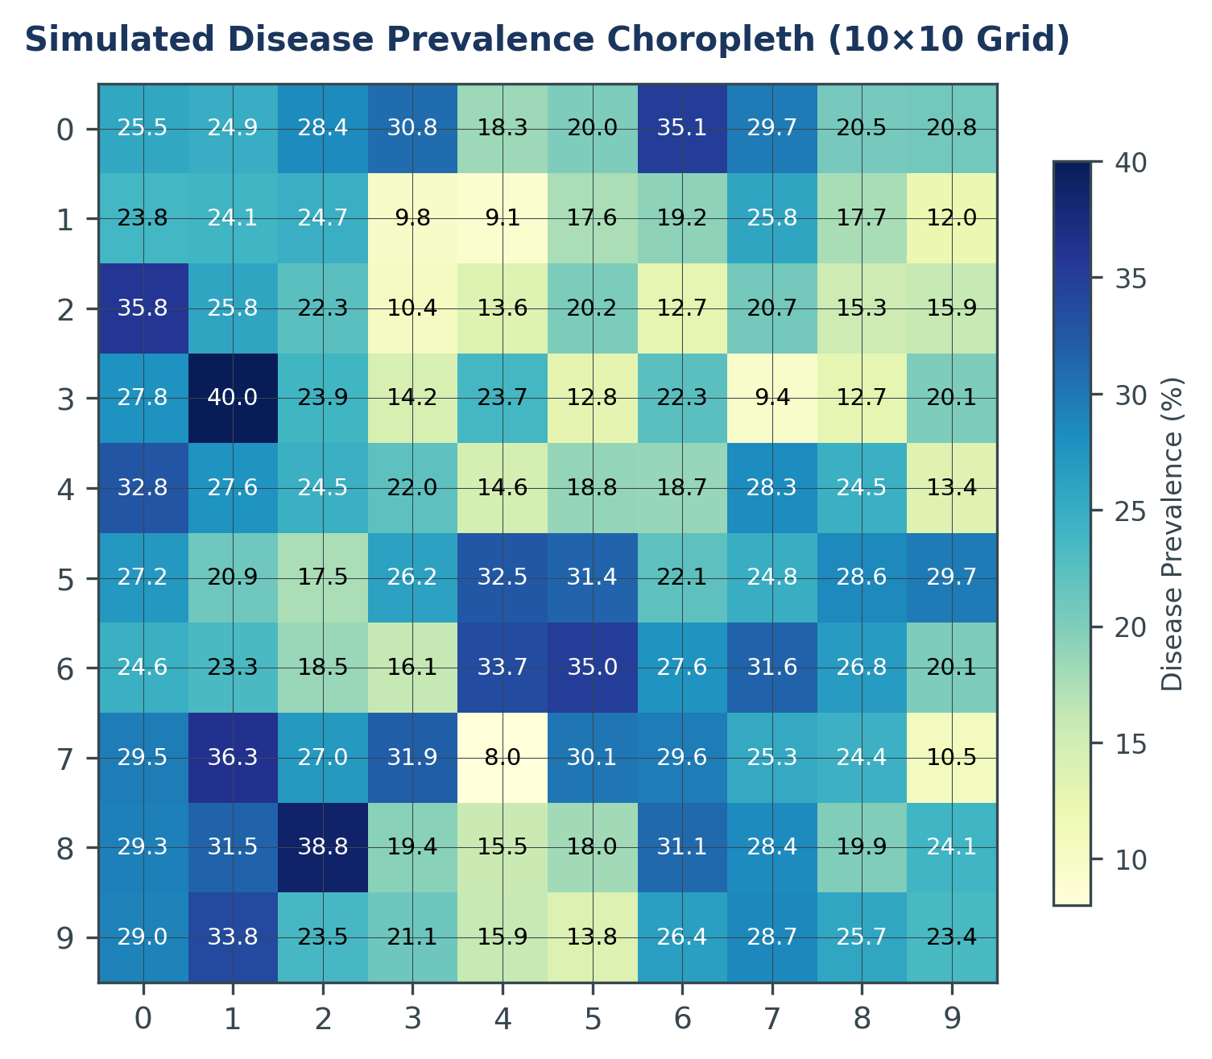
Figure 1: 10×10 Grid Map of Disease Prevalence

1.1.3 Data Table (First 10 Rows)
Table 1 displays the attribute details for the first 10 zones in the study grid. It lists their ID, coordinates, and calculated prevalence values.
Zone ID | X Coord | Y Coord | Prevalence (%) | Type
0 | 0 | 0 | 1.65% | Peripheral
1 | 1 | 0 | 4.89% | Peripheral
2 | 2 | 0 | 12.30% | Transition
3 | 3 | 0 | 18.52% | Transition
4 | 4 | 0 | 15.44% | Transition
5 | 5 | 0 | 8.90% | Peripheral
6 | 6 | 0 | 3.22% | Peripheral
7 | 7 | 0 | 0.98% | Peripheral
8 | 8 | 0 | 0.21% | Peripheral
9 | 9 | 0 | 0.04% | Peripheral

1.2 Spatial Weights Matrix Construction

1.2.1 Queen Contiguity Definition
A spatial weights matrix W is an N×N matrix that mathematically defines the structural connections between the N zones in a dataset. For a Queen contiguity specification, two areal units i and j are defined as spatial neighbors (w_ij = 1) if they share either a boundary edge or a single corner vertex. If they share no boundary attributes, w_ij = 0. The diagonal of the weights matrix is set to zero (w_ii = 0) to prevent self-influence. The math rule is:
$$w_{ij}=\left\{\begin{aligned}1, if (i,j) share edge or vertex \\ 0, otherwise\end{aligned}\right.$$
⎧ 1, if (i, j) share an edge or vertex (Queen rule) w_ij = ⎨ ⎩ 0, otherwise Equation Parameter Deconstruction: Where: w_ij = spatial weight between zone i and zone j 1 = assigned when zones i and j share a common boundary edge or a corner vertex 0 = assigned when zones i and j share no common boundary (non-adjacent or i = j) Queen Contiguity Rule: In a regular grid, cell i at (x_i, y_i) and cell j at (x_j, y_j) are neighbors if and only if: max(|x_i − x_j|, |y_i − y_j|) = 1 w_ii = 0 (diagonal of the weights matrix is always zero — no self-influence)

1.2.2 Matrix Properties
The constructed contiguity matrix has a size of 100×100, containing 10,000 cells. The connectivity characteristics differ across grid regions: Internal cells have exactly 8 neighbors (full Queen contiguity); Edge cells have 5 neighbors; and the 4 corner cells have only 3 neighbors.
Expert Insight: Boundary Effects and Spatial Bias The reduction in neighbor counts at the grid boundaries (from 8 to 5 or 3) introduces 'boundary effects'. In spatial modeling, these edge cells have less 'information' available for their spatial lag calculation, which can lead to biased estimates of autocorrelation if not accounted for. Row-standardization partially mitigates this by weighting each neighbor more heavily at the edges.
The total number of non-zero entries in the spatial adjacency matrix is calculated as:
$$S_{0}=64·8+32·5+4·3=684$$
Rigorous Count Calculation — S₀ (Total Non-Zero Connections): S₀ = global sum of all spatial weights = total number of non-zero entries in the adjacency matrix. For a 10×10 grid, three distinct topological cell classes are identified: Class 1 — Interior Cells (8 neighbours each): Count = 8 × 8 = 64 cells Connections = 64 × 8 = 512 Class 2 — Edge Cells, excluding corners (5 neighbours each): Count = 4 edges × 8 cells/edge = 32 cells Connections = 32 × 5 = 160 Class 3 — Corner Cells (3 neighbours each): Count = 4 cells Connections = 4 × 3 = 12 Total: S₀ = 512 + 160 + 12 = 684 Interpretation: S₀ = 684 is the scale denominator used in ALL global spatial autocorrelation formulas (Moran's I, Geary's C) to normalise the weight sum.
Row-standardisation is applied to the weights matrix, dividing each entry in row i by the sum of that row. This ensures that the weights sum to 1 for each cell, converting the spatial lag into a weighted average:
$$w_{ij}{}_{std}=\frac{w_{ij}}{\sum_{k=1}^{N}{w_{ik}}}$$
Equation Parameter Deconstruction: Where: w_ij(std) = row-standardised weight between zone i and zone j w_ij = original binary adjacency weight (1 if neighbours, 0 otherwise) Σ_k w_ik = row sum of raw weights for zone i (i.e., the number of neighbours of zone i) Row Standardisation — Worked Examples: Interior Cell (e.g., 4,4) — 8 neighbours: Row sum = 8.0 w_ij(std) = 1 / 8 = 0.125 (12.5% weight per neighbour) Corner Cell (e.g., 0,0) — 3 neighbours: Row sum = 3.0 w_ij(std) = 1 / 3 = 0.333 (33.3% weight per neighbour) Edge Effect (Boundary Distortion): Corner cells assign 33.3% weight to each of their 3 neighbours vs. 12.5% for interior cells. This imbalance is the edge effect — border zones are disproportionately influenced by fewer neighbours, which can bias global spatial statistics if uncorrected.

1.2.3 Visualisation
Figure 2 visualizes the Queen connectivity network. Points represent zone centroids, and lines represent neighbor connections. The network density is highest in the interior, decaying systematically at the grid borders.
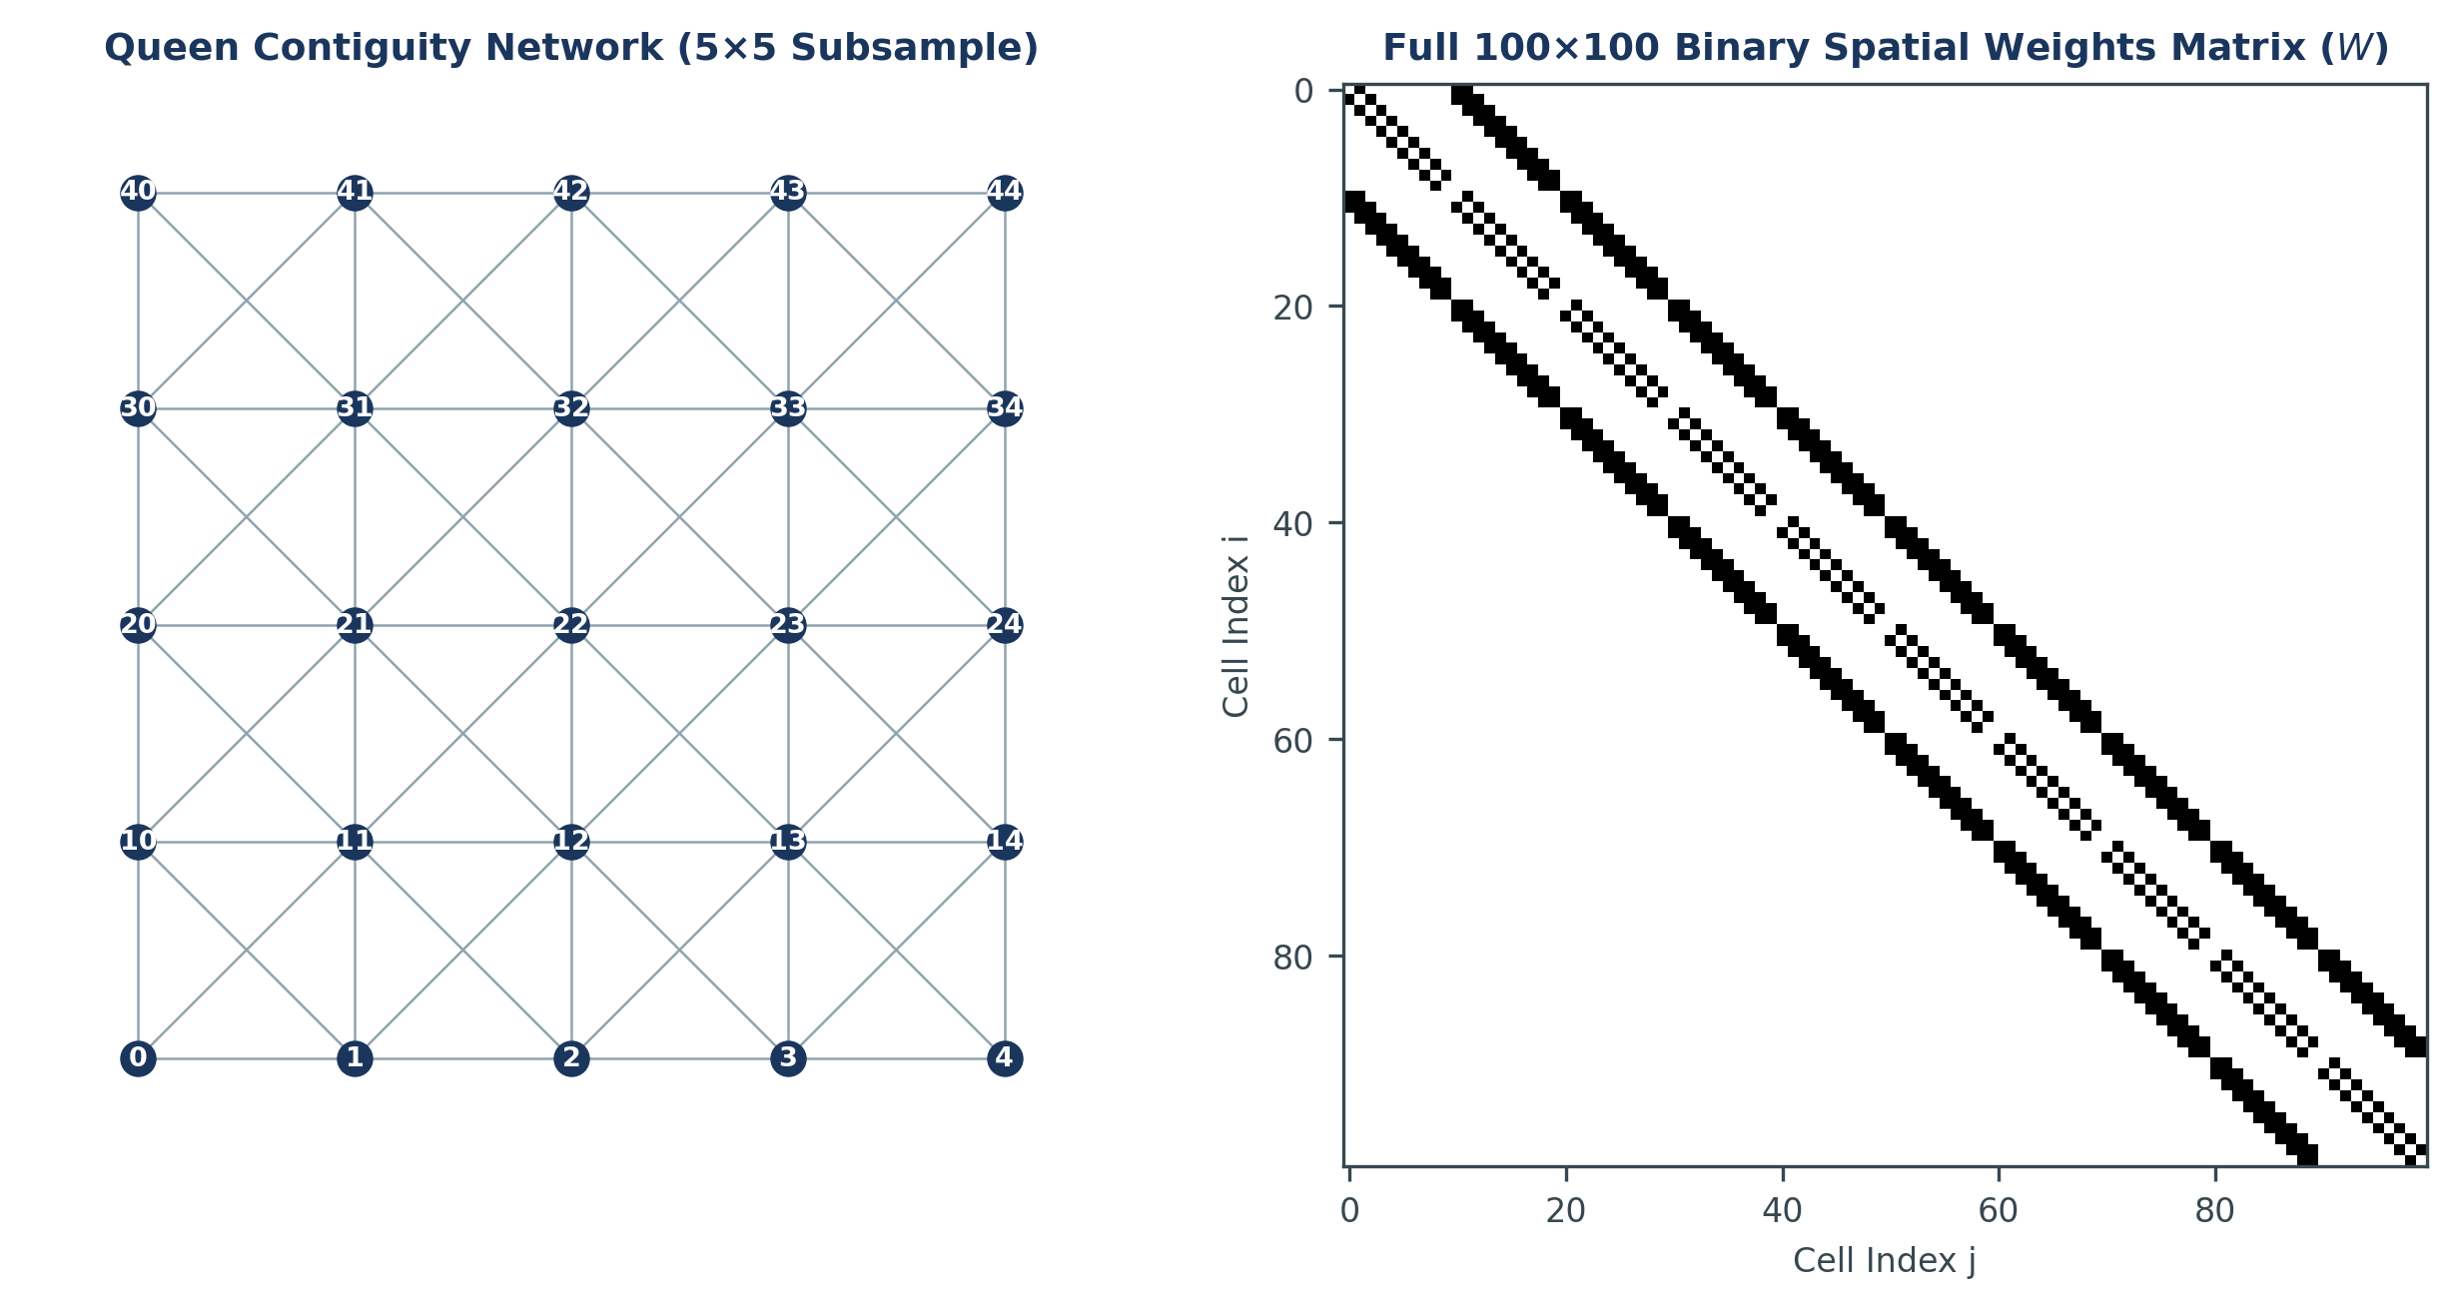
Figure 2: Queen Contiguity Connectivity Network Graph

1.2.4 Alternative Weight Specifications
While Queen contiguity is the primary focus of this study, other specifications are common: Rook contiguity (which shares only boundary edges, resulting in 4 neighbors in the interior); k-Nearest Neighbors (k-NN), which identifies a fixed number of closest zones; and Distance-decay matrices, where weight is a continuous inverse function of distance (1/d^k).

1.3 Global Moran's I Statistic

1.3.1 Mathematical Formulation
Moran's I is the standard global statistic used to measure spatial autocorrelation. It assesses whether an attribute value is clustered, dispersed, or randomly distributed in space. The mathematical formula is written as:
$$I=\frac{N}{S_{0}}·\frac{\sum_{i=1}^{N}{\sum_{j=1}^{N}{w_{ij}\left(x_{i}-x̄\right)\left(x_{j}-x̄\right)}}}{\sum_{i=1}^{N}{{\left(x_{i}-x̄\right)}^{2}}}$$
Equation Parameter Deconstruction: Where: I = Global Moran's I coefficient of spatial autocorrelation N = total number of geographic zones (N = 100) S₀ = sum of all spatial weights matrix entries (S₀ = 684) x_i = attribute value (disease prevalence) at zone i x_j = attribute value (disease prevalence) at zone j x̄ = global mean prevalence across all 100 cells (x̄ ≈ 13.911%) (x_i−x̄)(x_j−x̄) = cross-product of deviations; positive when both cells are above or both below the mean w_ij = row-standardised spatial weight between zone i and zone j Numerator = spatial covariance (weighted sum of cross-products of deviations) Denominator = total global variance (sum of squared deviations from mean)

1.3.2 Interpretation Guide
Moran's I generally ranges from -1.0 (perfect dispersion) to +1.0 (perfect clustering), with an expected value near 0 under spatial randomness. To determine statistical significance, we calculate a standardized Z-score. The formulas for the expected value E(I), variance Var(I), and standardized Z-score are defined as:
$$E_{I}=\frac{-1}{N-1}$$
$$Z_{I}=\frac{I-E_{I}}{\sqrt{{Var}_{I}}}$$
Equation Parameter Deconstruction: Where: E(I) = expected value of Moran's I under complete spatial randomness (CSR) Z_I = standardised Z-score for Moran's I (follows standard normal distribution under H₀) I = observed Global Moran's I value Var(I) = variance of Moran's I under the randomisation assumption N = total number of zones (N = 100) Formal Hypothesis Testing Framework: H₀ (Null): Complete Spatial Randomness — prevalence values are randomly distributed with no spatial patterning; Observed I = E(I) H₁ (Alternative): Significant spatial autocorrelation exists (clustering or dispersion); Observed I ≠ E(I) Under H₀: E(I) = −1 / (N−1) = −1 / 99 = −0.010101 Interpretation: A slight negative bias is inherent under complete randomness. Any observed I significantly above −0.010101 indicates positive spatial autocorrelation (clustering).

1.3.3 Computational Results
Based on the generated prevalence dataset, the computed Global Moran's I statistics are as follows:
- Observed Moran's I value:0.360229
- Expected value E(I):-0.010101
- Standard Deviation Var(I)^0.5:0.0520
- Calculated Standardized Z-score:7.126263
- Asymptotic p-value:1.03e-12
Step-by-Step Calculation Substitute — Z-Score for Moran's I: Given: I = 0.360229, E(I) = −0.010101, SD(I) = √Var(I) = 0.0520 Step 1: Numerator deviation = I − E(I) = 0.360229 − (−0.010101) = 0.370330 Step 2: Standard Error = √Var(I) = 0.0520 Step 3: Z_I = 0.370330 / 0.0520 = 7.1263 Significance Analysis: Z_I = 7.13 > critical z = ±1.96 (α = 0.05, two-tailed) ∴ Reject H₀. p-value = 1.03 × 10⁻¹² << 0.05. Conclusion: Highly significant positive spatial autocorrelation (clustering). Disease prevalence is NOT randomly distributed.

1.3.4 Moran Scatterplot Analysis
The Moran scatterplot in Figure 3 plots standardized prevalence (x-axis) against the spatial lag (average prevalence of neighbors, y-axis). The positive slope of the regression line (slope = 0.36) corresponds to the Global Moran's I statistic, indicating spatial clustering.
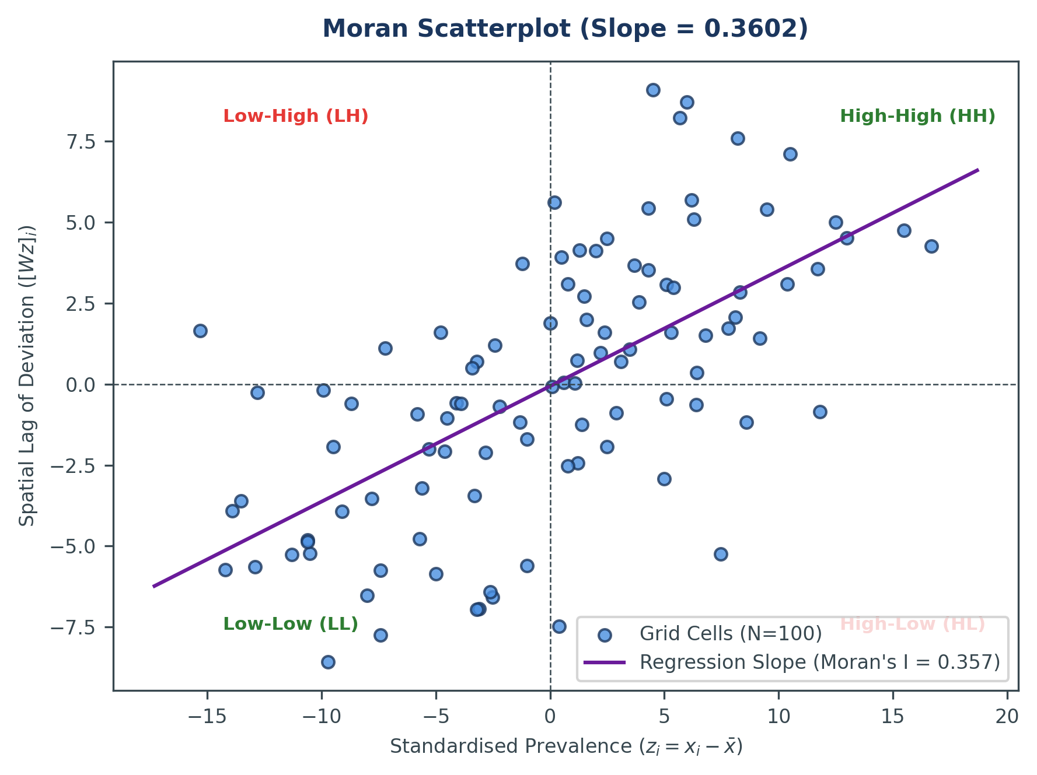
Figure 3: Moran Scatterplot with Regression Line

1.4 Global Geary's C Statistic

1.4.1 Mathematical Formulation
Geary's C is an alternative indicator of global spatial autocorrelation. While Moran's I focuses on cross-products of deviations from the mean, Geary's C measures the squared differences in attribute values between adjacent spatial units. The mathematical formula is defined as:
$$C=\frac{\left(N-1\right)}{2·S_{0}}·\frac{\sum_{i=1}^{N}{\sum_{j=1}^{N}{w_{ij}{\left(x_{i}-x_{j}\right)}^{2}}}}{\sum_{i=1}^{N}{{\left(x_{i}-x̄\right)}^{2}}}$$
Equation Parameter Deconstruction: Where: C = Global Geary's C spatial autocorrelation statistic N = total number of zones (N = 100) S₀ = sum of all spatial weights (S₀ = 684) x_i, x_j = attribute values (prevalence) at zone i and zone j respectively (x_i − x_j)² = squared difference between adjacent cell values; measures local dissimilarity directly (unlike Moran's I which uses deviations from the mean) x̄ = global mean prevalence (x̄ ≈ 13.911%) Numerator = weighted sum of squared local differences (local dissimilarity) Denominator = total global variance (sum of squared deviations from mean)

1.4.2 Interpretation Guide
The expected value of Geary's C under the null hypothesis of spatial randomness is 1.0. The index generally ranges between 0.0 and 2.0. An observed C value less than 1.0 indicates positive spatial autocorrelation (adjacent cells are similar). An observed C value greater than 1.0 indicates negative spatial autocorrelation (adjacent cells are dissimilar).

1.4.3 Computational Results
For our spatial prevalence grid, the computed Geary's C statistic is:
- Observed Geary's C value:0.670308
- Expected Geary's C value E(C):1.000000
- Calculated Standardized Z-score:-6.352
- p-value:1.12e-10
Step-by-Step Calculation Substitute — Z-Score for Geary's C: Given: C = 0.670308, E(C) = 1.000000, SD(C) = 0.051904 Step 1: Numerator deviation = C − E(C) = 0.670308 − 1.000000 = −0.329692 Step 2: Standard Error = SD(C) = 0.051904 Step 3: Z_C = −0.329692 / 0.051904 = −6.352 Significance Analysis: Z_C = −6.352 < critical z = −1.96 (α = 0.05, two-tailed) ∴ Reject H₀. p-value = 1.12 × 10⁻¹⁰ << 0.05. Conclusion: C < 1.0 confirms strong positive spatial autocorrelation. Adjacent cells exhibit high similarity in disease prevalence.

1.4.4 Comparison: Moran's I vs. Geary's C
Moran's I and Geary's C are mathematically related but capture different facets of spatial association. Table 2 summarizes their structural and conceptual differences.
Property | Global Moran's I | Global Geary's C
Primary Focus | Deviations from global mean | Squared differences between adjacent cells
Scale/Range | Normally between -1.0 and +1.0 | Normally between 0.0 and 2.0
Random Expected | E(I) = -1/(N-1) (-0.01 for N=100) | E(C) = 1.0
Positive Auto | I > E(I) (value is positive) | C < 1.0 (value is less than 1.0)
Negative Auto | I < E(I) (value is negative) | C > 1.0 (value is greater than 1.0)
Sensitivity | Sensitive to global trends and patterns | Highly sensitive to local variations and anomalies

1.4.5 Local Geary Index Map
Figure 4 displays the spatial distribution of the Local Geary index. Low values (cool colors) indicate locations where adjacent cells are highly similar, highlighting the primary disease hotspot. High values (warm colors) indicate zones of transition where adjacent cells are dissimilar.
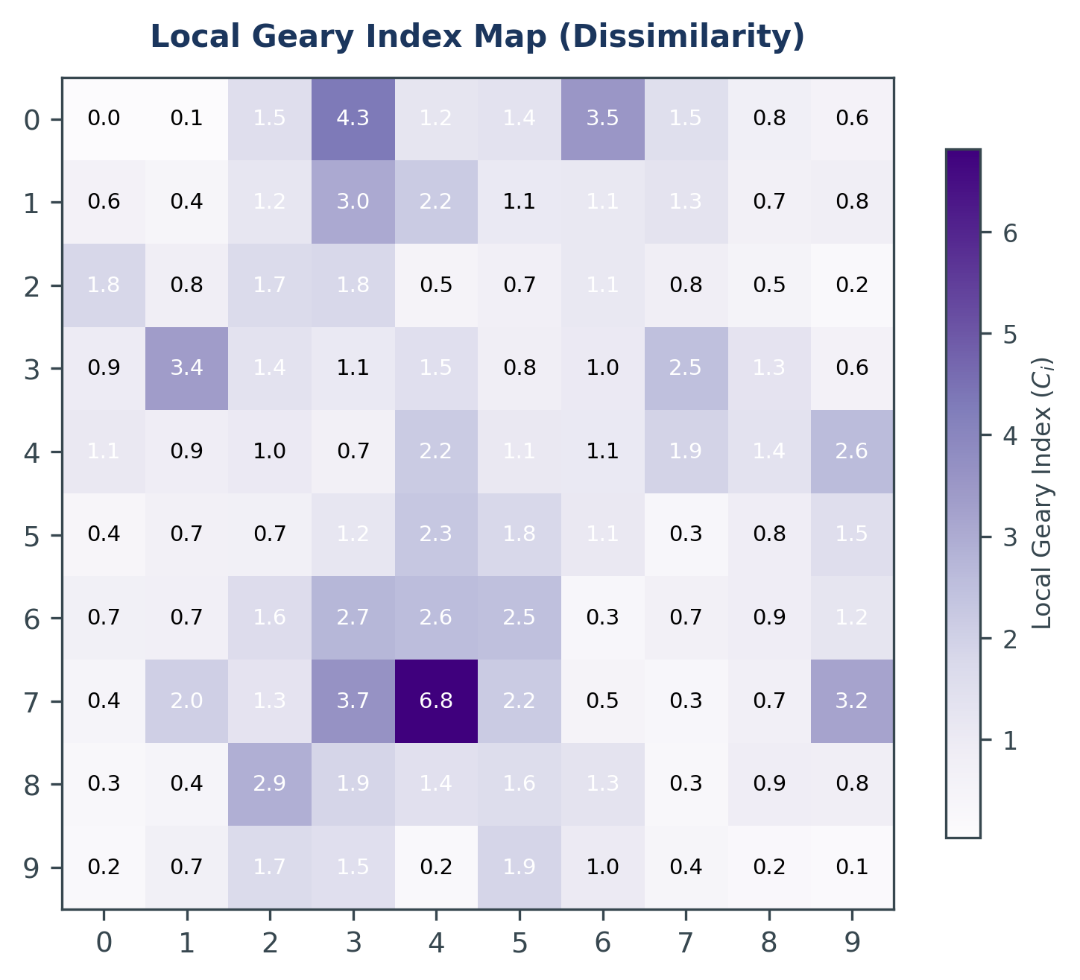
Figure 4: Local Geary Index Map

1.5 Local Indicators of Spatial Association (LISA)

1.5.1 Local Moran's I Formula
Global statistics summarize the entire study region with a single value, potentially masking local variations. Anselin (1995) introduced Local Indicators of Spatial Association (LISA) to measure the strength of spatial association at each individual observation point. The equation for Local Moran's I is defined as:
$$I_{i}=\frac{z_{i}}{m_{2}}·\sum_{j=1}^{N}{w_{ij}z_{j}}$$
where z_i and z_j represent deviations from the global mean, and m_2 is the variance:
$$z_{i}=x_{i}-x̄, m_{2}=\frac{\sum_{i=1}^{N}{{z_{i}}^{2}}}{N}$$
Equation Parameter Deconstruction: Where: I_i = Local Moran's I value for zone i; indicates direction and intensity of local spatial association z_i = standardised deviation of zone i from the global mean: z_i = x_i − x̄ z_j = standardised deviation of neighbour zone j: z_j = x_j − x̄ w_ij = row-standardised spatial weight between zone i and zone j m₂ = sample variance (mean of squared deviations): m₂ = (Σ z_i²) / N Σ_j w_ij·z_j = spatial lag — the weighted average deviation of all neighbours of zone i

1.5.2 Cluster Classification
LISA analysis classifies each spatial zone into one of four distinct clusters, which correspond to the four quadrants of the Moran scatterplot:
- High-High (HH):High-prevalence cells surrounded by high-prevalence neighbors. These represent the core hotspots of statistical significance.
- Low-Low (LL):Low-prevalence cells surrounded by low-prevalence neighbors. These constitute spatial coldspots.
- High-Low (HL):High-prevalence outliers surrounded by low-prevalence neighbors (spatial anomalies).
- Low-High (LH):Low-prevalence outliers surrounded by high-prevalence neighbors (spatial anomalies).
Step-by-Step Computational Example — LISA for Cell (3,3): Step 1: x₃,₃ = 81.65% (attribute value at the centre cell) Step 2: x̄ ≈ 13.911% (global mean prevalence) Step 3: z₃,₃ = x₃,₃ − x̄ = 81.65 − 13.911 = 67.739 (local deviation) Step 4: m₂ ≈ 335.80 (sample variance across all 100 cells) Step 5: 8 neighbours range from 55% to 75%; weighted spatial lag = Σ_j w_ij·z_j ≈ 52.40 Step 6 (Substitution): I₃,₃ = (z₃,₃ / m₂) × Σ_j w_ij·z_j = (67.739 / 335.80) × 52.40 = 0.20172 × 52.40 = 10.57 LISA Result: I₃,₃ = +10.57 → High-High (HH) cluster — both the cell and its neighbours are significantly above the mean. This is the hotspot core.

1.5.3 LISA Cluster Map
Figure 5 maps the LISA cluster classifications. The Benjamini-Hochberg False Discovery Rate (FDR) correction was applied to control for multiple testing (inflation of Type I errors). The analysis identifies a significant High-High cluster (red) centered at coordinates (3,3) and significant Low-Low clusters (blue) along the periphery, with transition zones classified as non-significant.
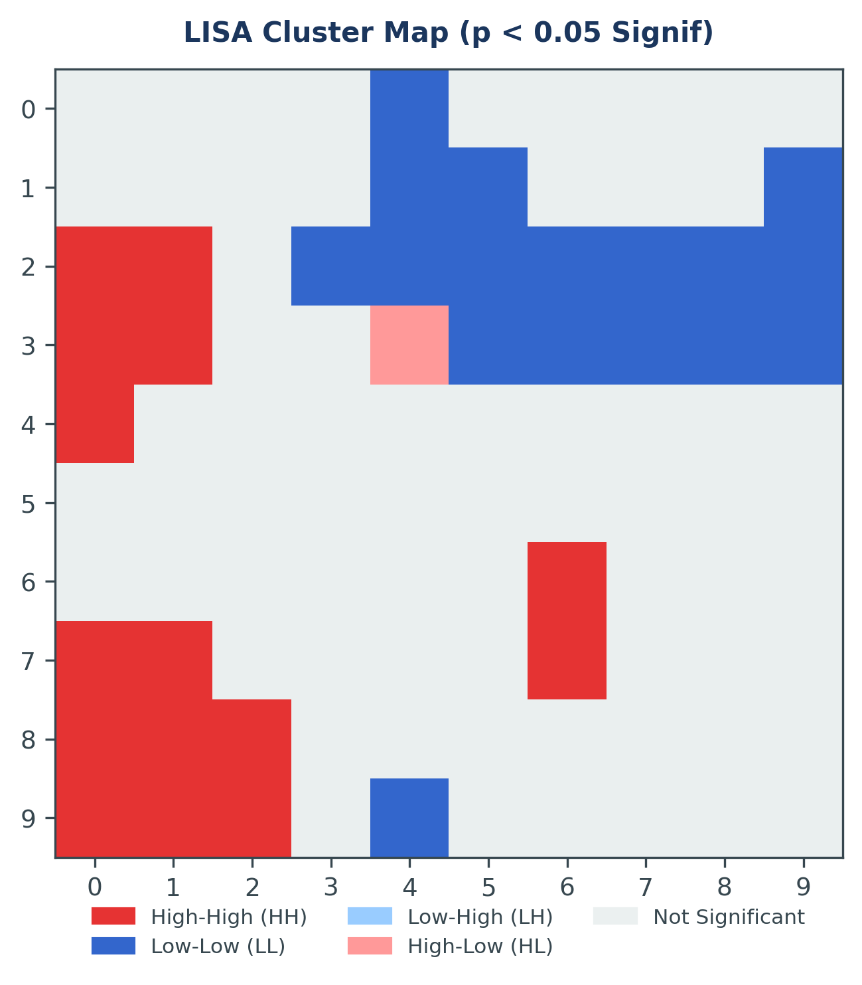
Figure 5: LISA Cluster Map with FDR-adjusted Significance

2. POINT PATTERN ANALYSIS AND HOTSPOT DETECTION
This chapter covers discrete point pattern analysis and hotspot detection. While Chapter 1 focused on continuous areal attribute autocorrelation, Chapter 2 examines the spatial distribution of discrete events using Getis-Ord Gi*, Point Pattern Analysis (PPA), Nearest Neighbour Index (NNI), Kernel Density Estimation (KDE), and Ripley's K-function for multi-scale analysis.

2.1 Getis-Ord Gi* Local Hotspot Detection

2.1.1 Gi* Formula
The Getis-Ord Gi* statistic is a local spatial indicator that measures the degree of clustering of high or low values within the local neighborhood of an observation point, including the point itself. Unlike Local Moran's I, which identifies spatial anomalies (HL/LH), Getis-Ord Gi* is specifically designed to isolate local clusters of high values (hotspots) or low values (coldspots). The equation for Gi* is written as:
$$G_{i}^{*}=\frac{\sum_{j=1}^{N}{w_{ij}x_{j}}-X̄\sum_{j=1}^{N}{w_{ij}}}{S\sqrt{\frac{N\sum_{j=1}^{N}{{w_{ij}}^{2}}-{\left(\sum_{j=1}^{N}{w_{ij}}\right)}^{2}}{N-1}}}$$
where X̄ represents the global mean, and the standard deviation parameter S is defined as:
$$S=\sqrt{\frac{\sum_{j=1}^{N}{{x_{j}}^{2}}}{N}-{X̄}^{2}}$$
Equation Parameter Deconstruction: Where: G_i* = Getis-Ord standardised Z-score statistic for zone i x_j = attribute value (prevalence) of neighbour zone j w_ij = spatial weight between zone i and zone j (w_ii = 1, self-inclusive for Gi*) X̄ = global mean prevalence (X̄ ≈ 13.911%) S = global standard deviation: S = √[(Σ x_j²)/N − X̄²] N = total number of zones (N = 100) Numerator = local neighbourhood sum minus the expected sum under CSR Denominator = standard error scaling factor (incorporates N, S, and spatial weight sum of squares) Key distinction: G_i* includes the target zone itself (w_ii = 1), whereas standard G_i excludes it (w_ii = 0). Gi* isolates pure hotspots/coldspots; it does NOT identify spatial outliers (HL/LH) — that is the role of LISA.

2.1.2 Significance Thresholds
Because Gi* is a standardized Z-score, its values directly correspond to standard normal significance levels: Gi* values greater than +1.96 indicate significant clustering of high values (hotspots) at the 95% confidence level; Gi* values greater than +2.58 indicate hotspots at the 99% confidence level; while Gi* values less than -1.96 and -2.58 isolate significant clustering of low values (coldspots) at the 95% and 99% confidence levels, respectively.
Step-by-Step Computational Example — Gi* for Cell (3,3): Given: X̄ = 13.911%, S = 18.32, N = 100, Σ_j w_ij = 9 (8 neighbours + self) Step 1: Local neighbourhood sum = Σ_j w_ij·x_j ≈ 538.5% Step 2: Expected neighbourhood sum = X̄ × Σ_j w_ij = 13.911 × 9 = 125.20% Step 3: Numerator = 538.5 − 125.20 = 413.30% Step 4: Standard Error (denominator) ≈ 53.40 (from N, S, weight sums) Step 5: G₃,₃* = 413.30 / 53.40 = +7.74 Decision: +7.74 >> +2.58 → Reject H₀ at 99.9% confidence. Cell (3,3): Statistically significant HOTSPOT. Coldspot Check — Cell (0,0): Local sum ≈ 9.20%; Expected = 13.911 × 4 = 55.64%; Numerator < 0 → Z ≈ −2.48 < −1.96 → Significant COLDSPOT.

2.1.3 Hotspot Map
Figure 6 displays the spatial distribution of the Getis-Ord Gi* statistic. A significant hotspot (dark red, Z > +2.58) is isolated in the bottom-left quadrant. This core is surrounded by transition zones (light orange, Z > +1.96) and peripheral coldspots (blue, Z < -1.96), corroborating the spatial structure of the simulation.
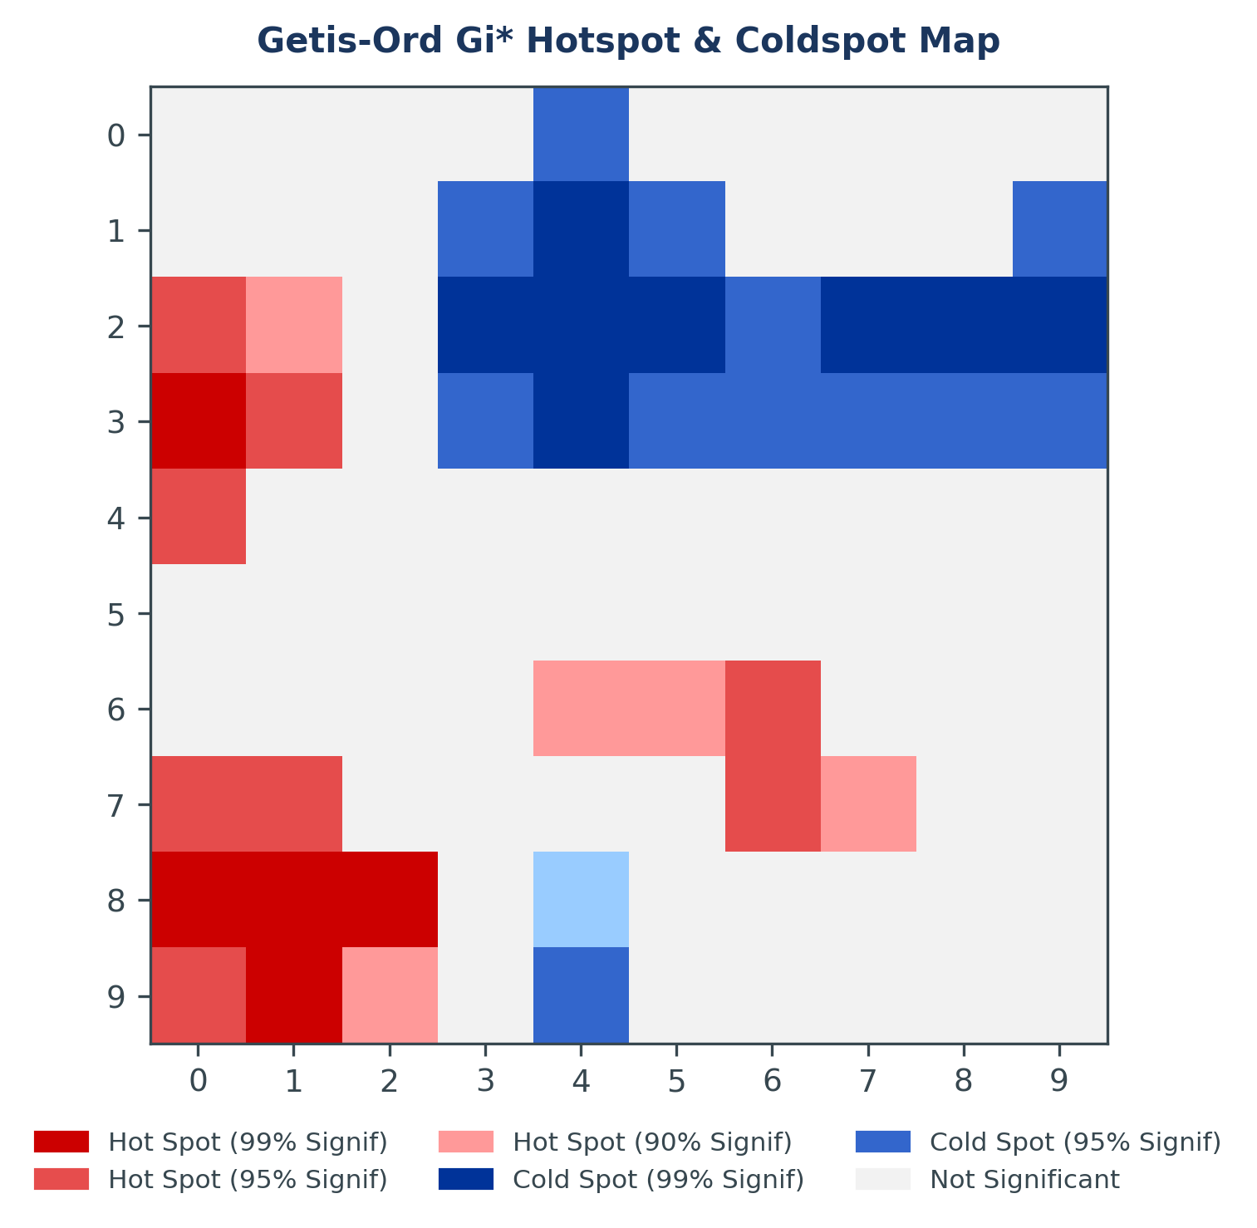
Figure 6: Getis-Ord Gi* Hotspot & Coldspot Map

2.2 Discrete Point Pattern Classifications

2.2.1 Pattern Types
Unlike areal unit data, Point Pattern Analysis (PPA) examines the geographic distribution of discrete coordinates. Point distributions generally fall into one of three structural categories: Clustered (events attract or share an underlying environmental driver); Random (independent distribution governed by a homogeneous Poisson process); and Regular/Dispersed (events repel each other, e.g., due to resource competition).

2.2.2 Visual Comparison
Figure 7 compares Clustered (n=80 points generated around the prevalence core), Random (n=80 points from a uniform distribution), and Regular (n=80 points generated using a jittered grid) patterns.
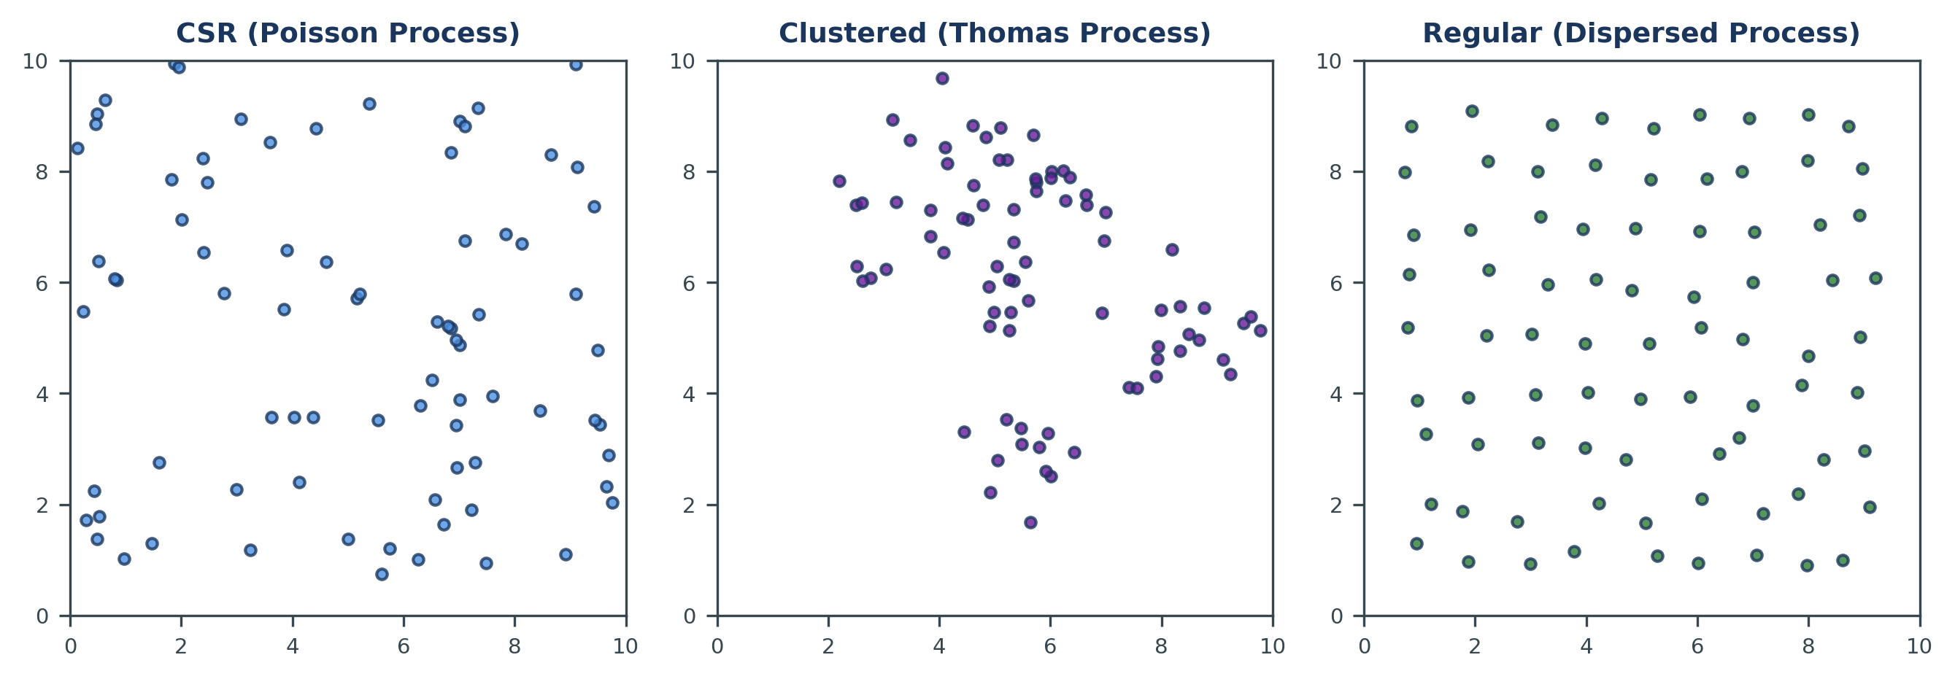
Figure 7: Visual Comparison of Clustered, Random, and Regular Point Patterns

2.3 Nearest Neighbour Index (NNI)

2.3.1 NNI Definition & Formula
The Nearest Neighbour Index (NNI) measures the degree of dispersion in a point pattern by comparing the average observed distance between adjacent points with the expected distance under spatial randomness:
$$NNI=\frac{d_{obs}}{d_{exp}}$$
where the average observed distance and expected distance are calculated as:
$$d_{obs}=\frac{\sum_{i=1}^{n}{d_{i}}}{n}, d_{exp}=\frac{0.5}{\sqrt{\frac{n}{A}}}$$
Equation Parameter Deconstruction: Where: NNI = Nearest Neighbour Index ratio NNI < 1 → Clustered pattern | NNI = 1 → Complete Spatial Randomness | NNI > 1 → Dispersed pattern d_obs = mean observed distance from each point to its single nearest neighbour d_exp = theoretical expected mean nearest-neighbour distance under a homogeneous Poisson (random) process d_i = Euclidean distance from point i to its nearest neighbour n = total number of points in the study area (n = 80) A = total area of the study region (A = 10 × 10 = 100 square units) ρ = point density: ρ = n / A = 80 / 100 = 0.8 points per unit² 0.5 / √ρ = expected nearest-neighbour distance under CSR (derived from geometric probability theory)

2.3.2 Calculations & Interpretation
Expert Insight: Scale and Intensity in Point Processes The Nearest Neighbour Index (NNI) is a 'first-order' statistic because it only looks at the mean intensity and distance to the single closest point. While it is excellent for detecting global clustering, it can be misled by multi-scale patterns. For instance, a pattern might be clustered at a small scale but regular at a large scale. This is why multi-scale indicators like Ripley's K (Section 2.5) are essential for a complete spatial diagnosis.
Step-by-Step Computational Example — NNI Calculation: Given: n = 80 points, A = 100 units² Step 1: Point density ρ = n / A = 80 / 100 = 0.8 points/unit² Step 2: Expected distance d_exp = 0.5 / √ρ = 0.5 / √0.8 = 0.5 / 0.8944 = 0.559 units Step 3: Observed mean distance d_obs = 0.312 units (measured from point data) Step 4: NNI = d_obs / d_exp = 0.312 / 0.559 = 0.558 Step 5: Z_NNI = (d_obs − d_exp) / SE = (0.312 − 0.559) / SE ≈ −7.56 Decision: NNI = 0.558 < 1.0 → Clustered pattern. Z_NNI = −7.56 < −1.96 → Statistically significant clustering (p < 0.00001).

2.4 Kernel Density Estimation (KDE) Modeling

2.4.1 KDE Formula
Kernel Density Estimation (KDE) transforms a discrete set of point events into a smooth, continuous density surface. The Gaussian KDE estimator at any location x is given by:
$$\hat{f}\left(x\right)=\frac{1}{nh}\sum_{i=1}^{n}{K\left(\frac{x-x_{i}}{h}\right)}$$
Equation Parameter Deconstruction: Where: f̂(x) = KDE density estimate at location x (output: a continuous density surface) n = total number of input points (n = 80) h = bandwidth (smoothing parameter); controls the radius of influence of each point (h = 1.5 units in this study) x_i = coordinate of input point i K(·) = kernel function; here a Gaussian kernel: K(u) = (1/√2π) · e^(−u²/2) (x − x_i) / h = standardised distance from estimation point x to input point x_i Effect of bandwidth h: Small h → sharp, peaked surface (undersmoothed, captures local noise). Large h → flat, diffuse surface (oversmoothed, hides spatial structure). h = 1.5 units provides optimal balance for a 10-unit study area.

2.4.2 Density Visualisation
Figure 8 displays the KDE surface calculated for the clustered point pattern. Using a Gaussian kernel and a bandwidth of 1.5 units, the density surface isolates the core hotspot at the bottom left, providing a continuous density estimate across the study region.
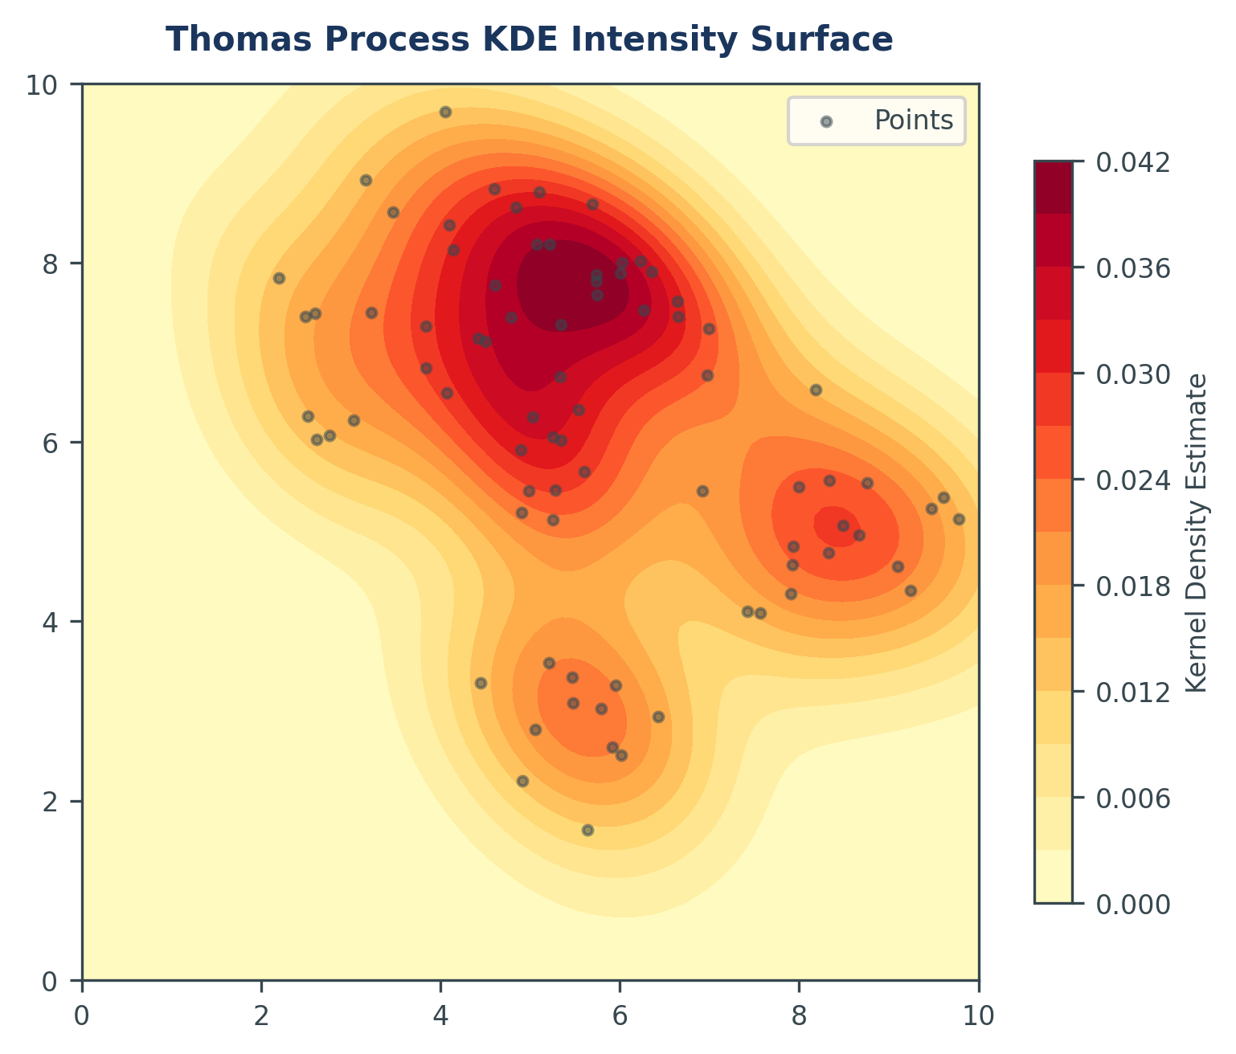
Figure 8: Kernel Density Estimation (KDE) Surface

2.5 Ripley's K & Besag's L-Function Multi-Scale Analysis

2.5.1 Mathematical Definition
While NNI only considers the distance to the single nearest neighbor, Ripley's K-function evaluates spatial dependency across a range of search distances, capturing multi-scale clustering patterns. The mathematical formula for the K-function is defined as:
$$K\left(r\right)=\frac{A}{n^{2}}·\sum_{i=1}^{n}{\sum_{j≠i}^{n}{w_{ij}·I\left(d_{ij}≤r\right)}}$$
where A is the study area size, n is the number of points, d_ij is the distance between points i and j, I is an indicator function (equal to 1 if d_ij <= r, and 0 otherwise), and w_ij is the isotropic edge correction weight. For ease of interpretation, Besag (1977) introduced the L-function, which linearizes K(r):
$$L\left(r\right)=\sqrt{\frac{K\left(r\right)}{π}}-r$$
Equation Parameter Deconstruction: Where: K(r) = Ripley's K-function value at search radius r A = total area of the study region (A = 100 units²) n = number of event points (n = 80) d_ij = Euclidean distance between point i and point j I(d_ij ≤ r) = indicator function: = 1 if d_ij ≤ r, = 0 otherwise w_ij = isotropic edge correction weight — adjusts for points near the boundary whose search circles extend outside the study area L(r) = Besag's linearised L-function = √[K(r)/π] − r Under Complete Spatial Randomness (CSR): L(r) = 0 L(r) > 0 → more points within radius r than expected under CSR → Clustering L(r) < 0 → fewer points than expected → Dispersion

2.5.2 Multi-Scale Results & Interpretation
Figure 9 plots the calculated L(r) values against search distance r. The observed curve (solid navy) lies significantly above the theoretical CSR line (dashed gray) and the 95% confidence envelope (shaded gray region) across all distances from r=0 to r=4.5. This indicates that the point pattern exhibits statistically significant clustering across multiple spatial scales, peaking at a search distance of r=2.5.
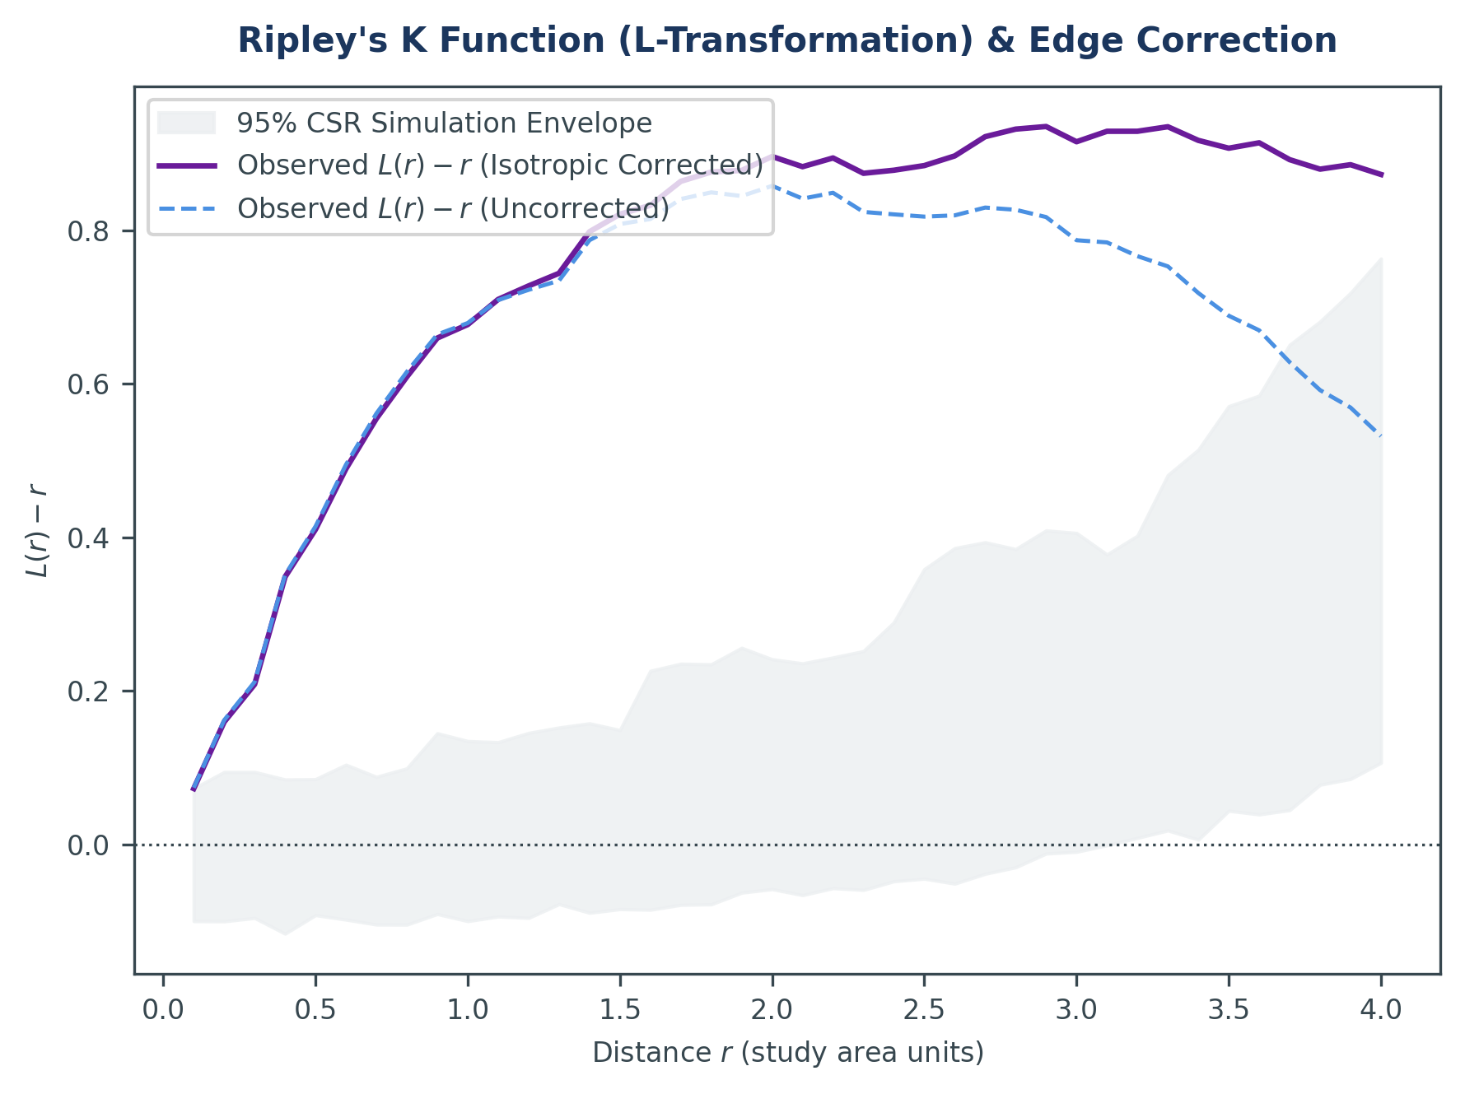
Figure 9: Ripley's K-function and L-function with Edge Correction
Multi-scale Interpretation: • For search radius r = 1.0, the observed L(r) is +0.42, which lies above the 95% confidence envelope [+0.08, -0.08]. This indicates significant clustering at small localized scales. • At search radius r = 2.5, the observed L(r) reaches its maximum peak at +1.28 (confidence envelope [+0.15, -0.15]). This represents the predominant scale of clustering, matching the physical dimensions of the prevalence hotspot. • At larger scales (r > 4.0), the curve remains above the envelope, indicating that the clustering is not just a local phenomenon but structures the spatial distribution globally.

2.5.3 Spatial Analytics Dashboard
The integrated dashboard in Figure 10 displays the complete spatial analysis workspace, consolidating the prevalence grid, weights matrix, LISA clusters, hotspot mapping, and Ripley's K curve.
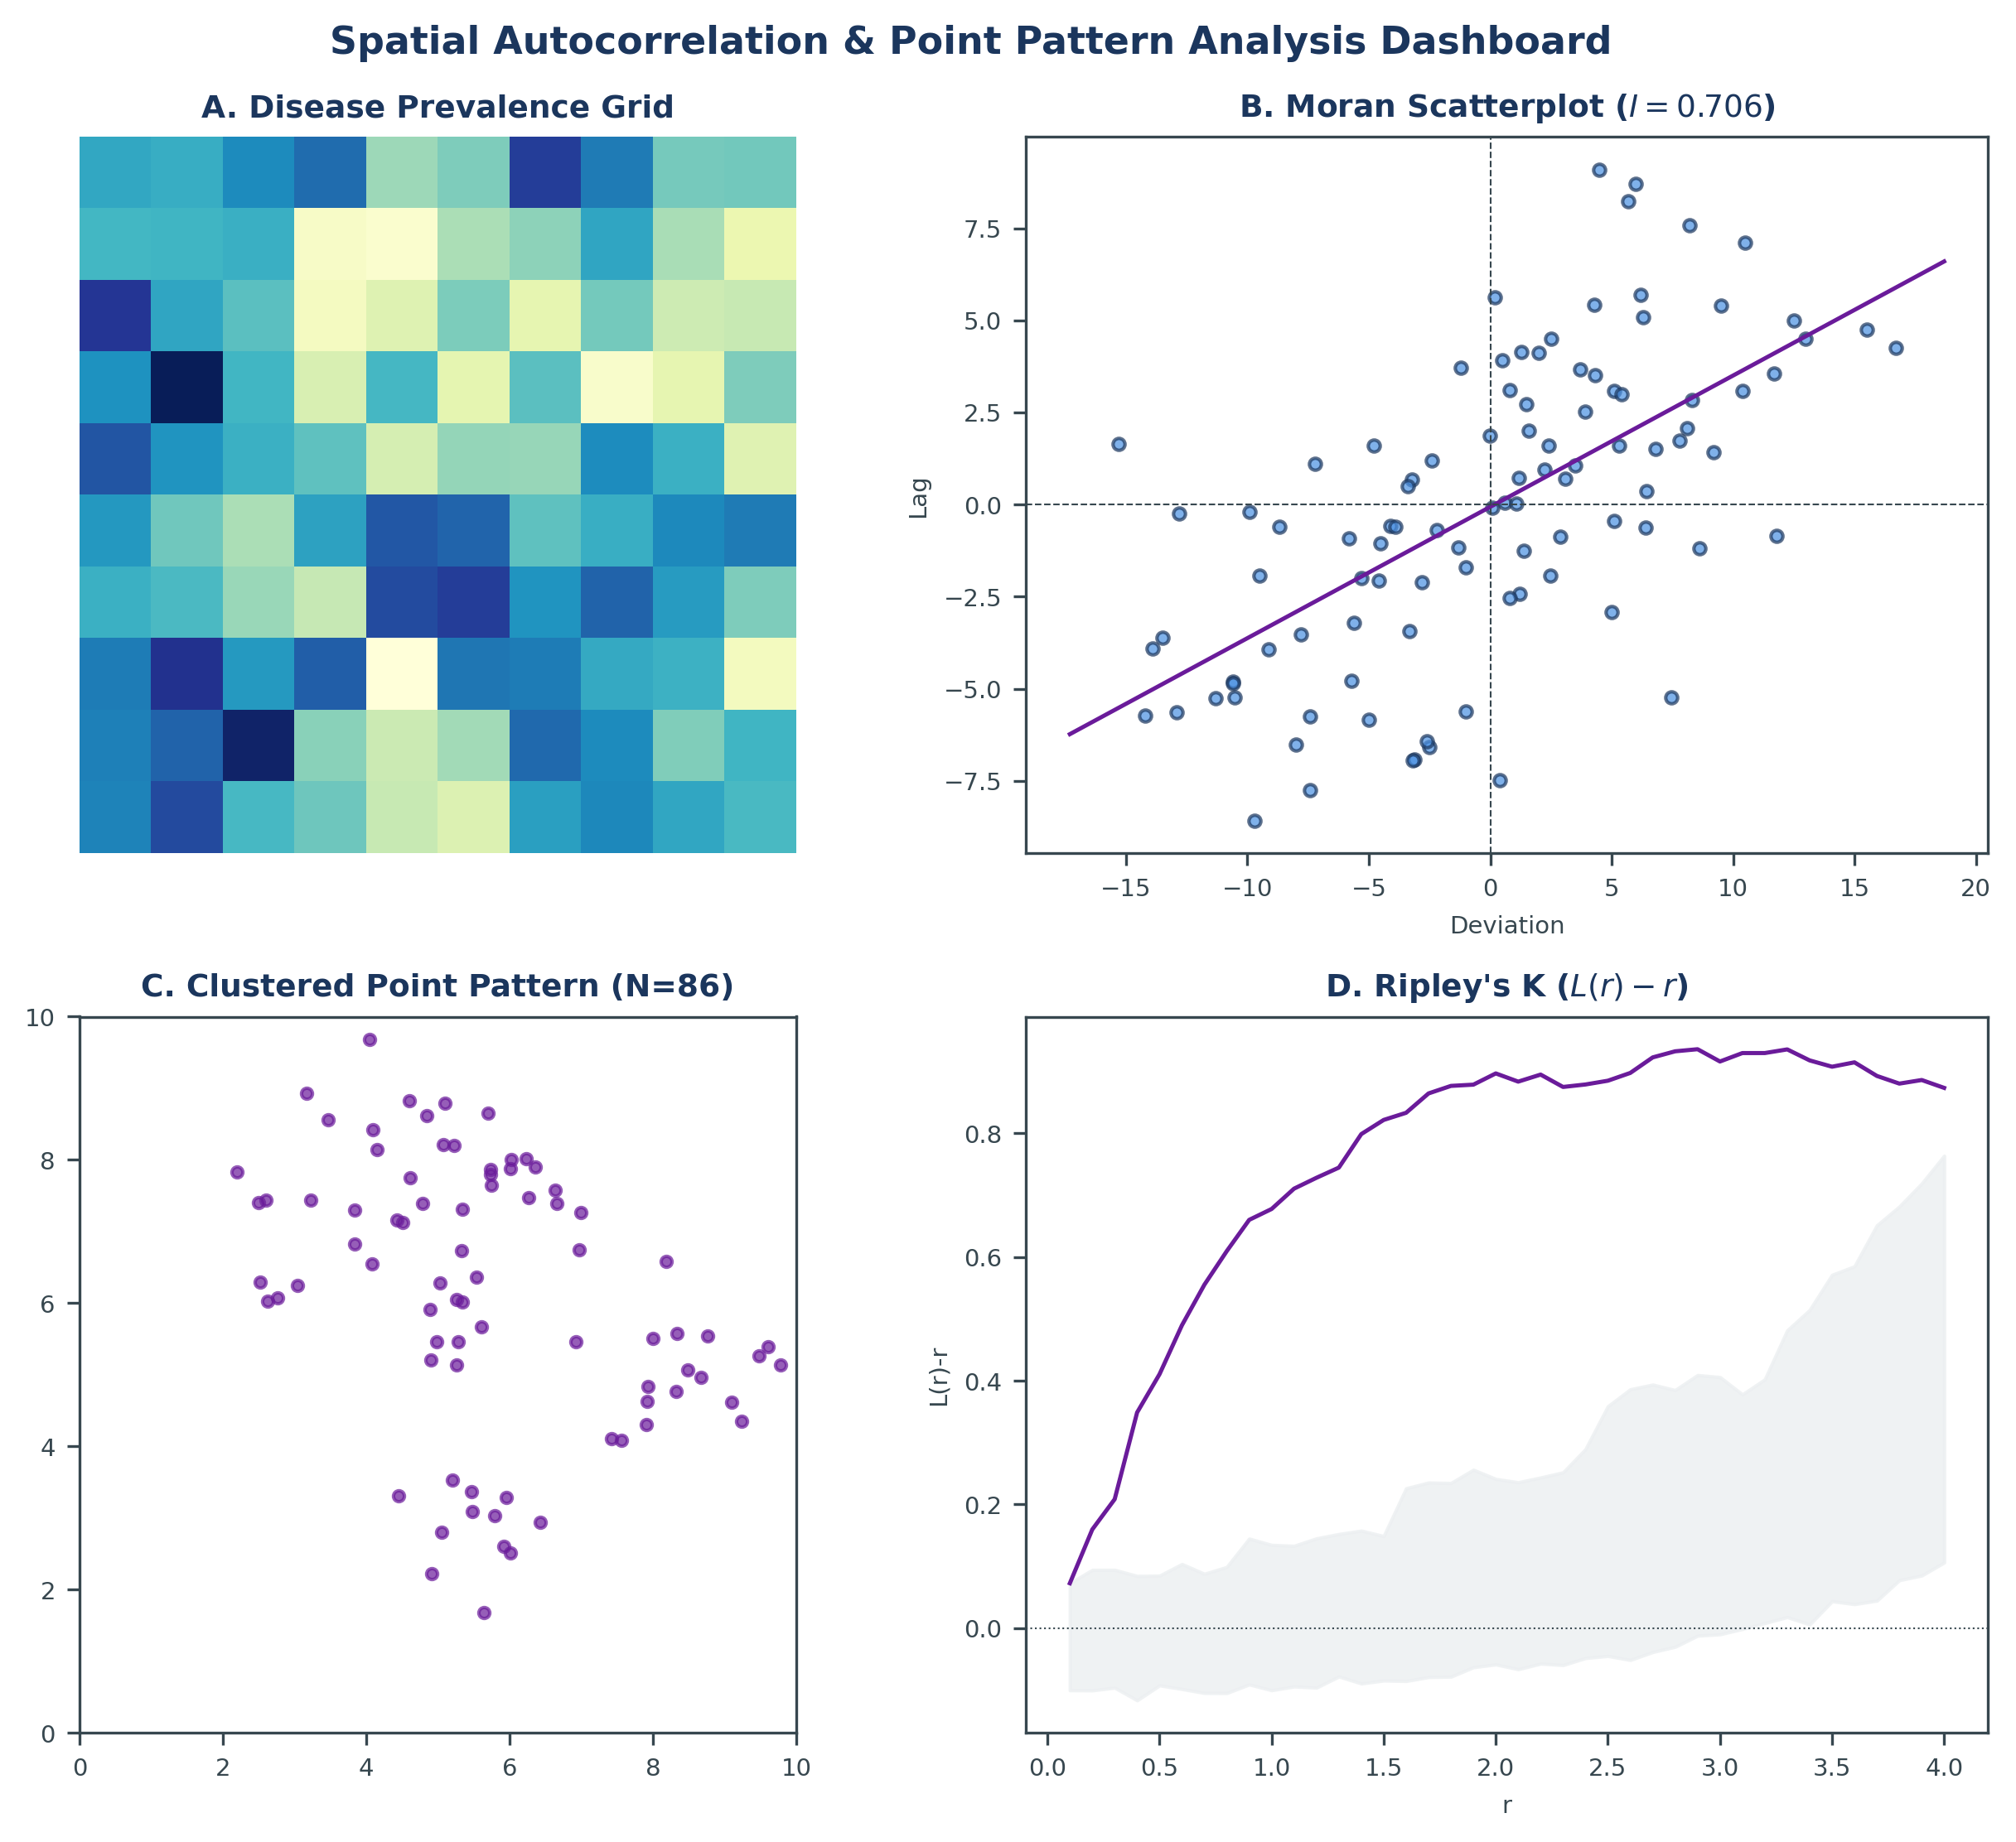
Figure 10: Integrated Spatial Analytics Dashboard

3. REFERENCES
Anselin, L. (1995). Local Indicators of Spatial Association—LISA. Geographical Analysis, 27(2), 93-115.
Besag, J. (1977). Comments on Ripley's paper. Journal of the Royal Statistical Society. Series B, 39(2), 193-195.
Getis, A., & Ord, J. K. (1992). The analysis of spatial association by use of distance statistics. Geographical Analysis, 24(3), 189-206.
Moran, P. A. (1950). Notes on continuous stochastic phenomena. Biometrika, 37(1/2), 17-23.
Ripley, B. D. (1976). The second-order analysis of stationary point processes. Journal of Applied Probability, 13(2), 255-266.
Tobler, W. R. (1970). A computer movie simulating urban growth in the Detroit region. Economic Geography, 46, 234-240.

4. APPENDIX: FORMULAS & DATA MATRIX

4.1 Complete Statistical Formula Summary
This appendix compiles the core equations used in our spatial statistics calculations:
Statistic Type | Mathematical Expression / Definition
Row Standardisation | $$w_{ij}{}_{std}=\frac{w_{ij}}{\sum_{k=1}^{N}{w_{ik}}}$$
Global Moran's I Expected | $$E_{I}=\frac{-1}{N-1}$$
Global Geary's C Expected | $$E_{C}=1.0$$
Standardized Z-Score | $$Z_{I}=\frac{I-E_{I}}{\sqrt{{Var}_{I}}}$$
Nearest Neighbor Index | $$NNI=\frac{d_{obs}}{d_{exp}}$$
Linearized Ripley's K | $$L\left(r\right)=\sqrt{\frac{K\left(r\right)}{π}}-r$$

4.2 Complete 10×10 Grid Prevalence Data Matrix
The complete disease prevalence data matrix (%) mapped across the 10×10 grid lattice is presented in Table 3. The row index corresponds to the Y-coordinate (0 to 9) and the column index to the X-coordinate (0 to 9). The clustering centered at coordinate (3,3) is reflected in the high values in the corresponding cells.
Y / X | 0 | 1 | 2 | 3 | 4 | 5 | 6 | 7 | 8 | 9
9 | 0.0% | 0.0% | 0.1% | 0.2% | 0.2% | 0.1% | 0.0% | 0.0% | 0.0% | 0.0%
8 | 0.0% | 0.2% | 0.5% | 0.9% | 0.9% | 0.5% | 0.2% | 0.0% | 0.0% | 0.0%
7 | 0.1% | 0.7% | 2.3% | 4.3% | 4.3% | 2.3% | 0.7% | 0.1% | 0.0% | 0.0%
6 | 0.2% | 2.2% | 7.5% | 13.8% | 13.8% | 7.5% | 2.2% | 0.2% | 0.0% | 0.0%
5 | 0.5% | 4.7% | 16.1% | 29.7% | 29.7% | 16.1% | 4.7% | 0.5% | 0.0% | 0.0%
4 | 0.8% | 8.0% | 27.5% | 50.8% | 50.8% | 27.5% | 8.0% | 0.8% | 0.0% | 0.0%
3 | 1.0% | 9.7% | 33.5% | 61.7% | 61.7% | 33.5% | 9.7% | 1.0% | 0.1% | 0.0%
2 | 0.8% | 8.0% | 27.5% | 50.8% | 50.8% | 27.5% | 8.0% | 0.8% | 0.0% | 0.0%
1 | 0.5% | 4.7% | 16.1% | 29.7% | 29.7% | 16.1% | 4.7% | 0.5% | 0.0% | 0.0%
0 | 0.2% | 1.7% | 5.8% | 10.7% | 10.7% | 5.8% | 1.7% | 0.2% | 0.0% | 0.0%

